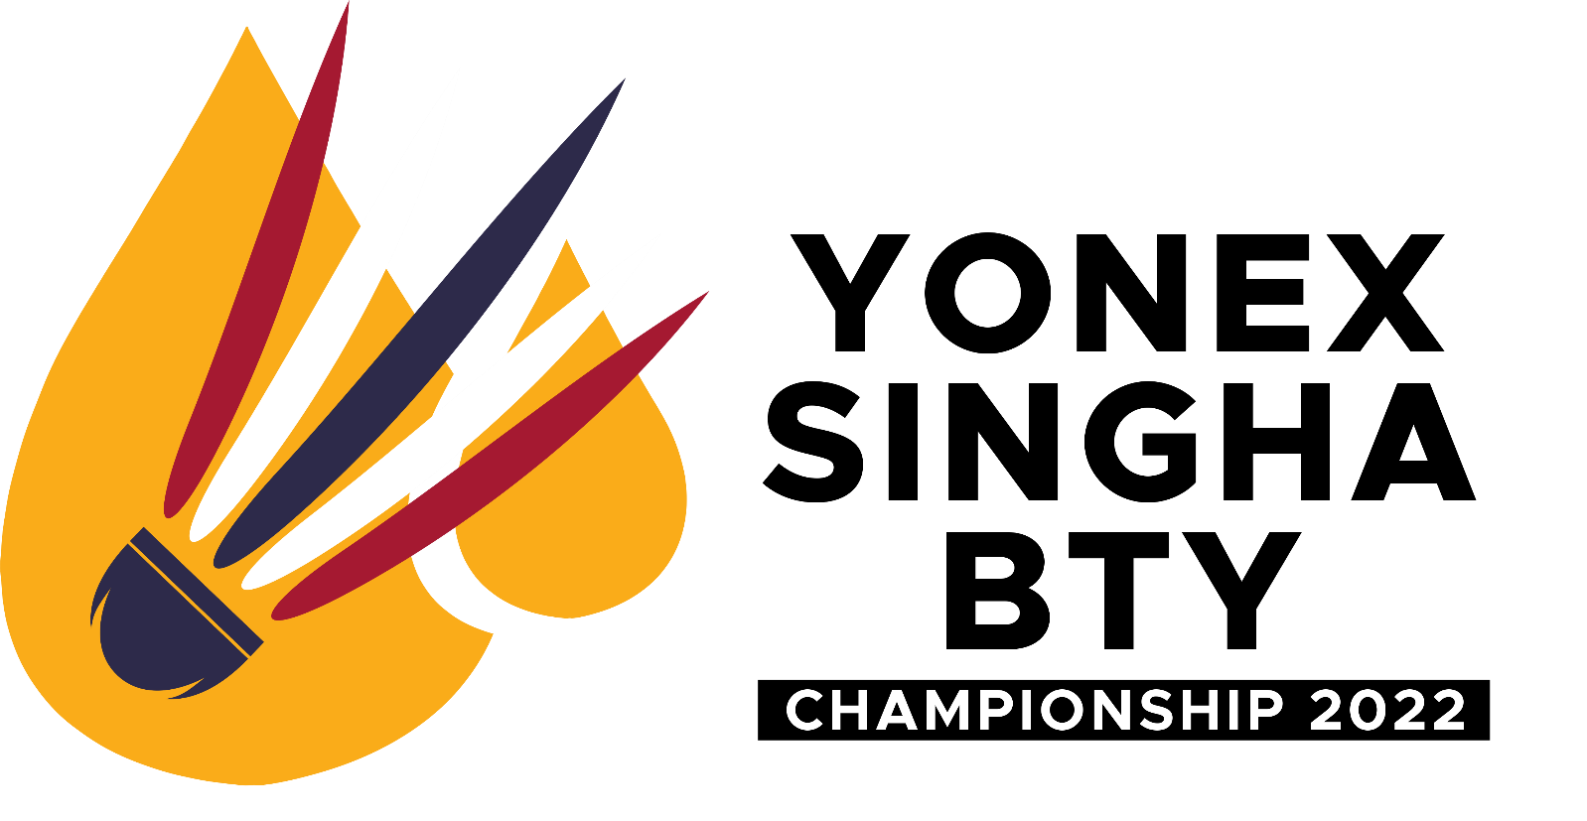

INVITATION
BANGKOK, THAILAND
NOVEMBER 2nd – 7th, 2022
at Banthongyord Badminton School

U-9, U-11, U-13, U-15, U-17, U-19 and Open
Thai player Closing Date: October 12th, 2022
Inter-player closing date for sending passport copy: October 5th, 2022

ORGANIZER
Banthongyord Badminton School known as BTY
136/7 Phutthamonton Sai 3 Road, Bangphai, Bangkhae, Bangkok,
10160 Thailand
Email : btytournament.thai@gmail.com
SANCTIONED BY
The Badminton Association of Thailand under Royal Patronage of His Majesty the King (BAT)
COMPETITION VENUE
Banthongyord Badminton School
136/7 Phutthamonton Sai 3 Road, Bangphai, Bangkhae, Bangkok, 10160 Thailand
CHAMPIONSHIP DATES
For U-9, U-11, U-l 3, U-l5, U-l7 U-19 and Open
November 2nd, 2022 to November 7th, 2022
Note: The schedule is subject to change at the discretion of the Referee
CLOSING DATES
- U-9, U-11, U-l 3, U-l5, U-l7, U-19 and Open:
- Thai player closed October 12th, 2022
- International player closed for sending passport copy October 5th, 2022

EVENTS
- The Organizers reserve the right to cancel any of the above events and/or reduce the prize money should the entries be deemed insufficient.
- Update of such information shall be disseminated to all participating countries within 7 days from the closing date for entries.
- For avoidance of doubt, please take note of the age category condition:

Age Category | Must Born in or After | Category
Under - 9 | 2014 | BS | GS | BD | GD | -
Under - 11 | 2012 | BS | GS | BD | GD | -
Under - 13 | 2010 | BS | GS | BD | GD | -
Under - 15 | 2008 | BS | GS | BD | GD | XD
Under - 17 | 2006 | BS | GS | BD | GD | XD
Under - 19 | 2004 | BS | GS | BD | GD | XD
Open | Open | MS | WS | MD | WD | XD

- For U-9, U-l 1, U-13, U-15, U-17, U-19 and Open no need BWF ID through email: : btytournament.thai@gmail.com

IMPORTANT NOTE!!!
All entries must attach photo copy of player passport
NOT LATER THAN October 5th, 2022

- 1. The player can be applied not more than 2 ages, is in own player age and higher in 1 age, but all total to submit not more than 3 events.
- All entries must be made using the Entry Form (Please refer to attachment Appendix A)
- Entries close on October 12th, 2022 for Thai player and close on October 5th, 2022 for sending passport copy of international player. (U-9, U-11, U-13, U-15, U-17, U-19 and Open)
- Late entries may be rejected at the discretion of the organizer.
- Entries submitted by National Associations must be in ranked order for all events.
- National Associations will be notified whether their players have been accepted into the tournament or are placed in the reserved list as soon as possible, after the closing date. The information will be published and updated on the website: https://www.facebook.com/banthongyord
- If there are less than 16 entries for any event after the closing date, that event may be cancelled.

Team Managers Meeting
For U-9, U-11, U-13, U-15, U-17, U-19 and Open
Date: November 1st, 2022 at 8.00 hrs.
Venue: Banthongyord Badminton School
136/7 Phutthamonton Sai 3 Road, Bangphai, Bangkhae, Bangkok, 10160 Thailand

REGISTRATION FEES
The registration fees for each event are as follows:
- U-9, U-11, U-13, U-15, U-17, U-19:
- For foreign players are Single – 20 USD per player, Double – 40 USD per pair. + 40 USD (Thailand bank service charge)
- For Thai players are Single – 450 Baht per player, Double – 900 Baht per pair.

Open:
➡ For foreign players are Single – 20 USD per player, Double – 40 USD per pair. + 40 USD (Thailand bank service charge)
➡ For Thai players are Single – 500 Baht per player, Double – 1,000 Baht per pair.

* Registration fee is non-refundable.
** For foreign players, bank of Thailand service charge 40 USD per transaction.

CONDITIONS FOR ENTRIES
The organizers will NOT be responsible for any injury sustained, at any time, by any player or official arising from his participation in this tournament. Any costs incurred for medical treatment and / or hospitalization shall be borne by the Member Association of the player/official concerned.

SCHEDULE COMPETITIONS

Date | Time | Program
Wednesday, 2nd November 2022 | 9.00 AM | Qualify
Thursday, 3rd November 2022 | 9.00 AM | Qualify
Friday, 4th November 2022 | 9.00 AM | Main Draw & R16
Saturday, 5th November 2022 | 9.00 AM | Quarter Final (R8)
Sunday, 6th November 2022 | 9.00 AM | Semi Final (R4)
Monday, 7th November 2022 | 9.00 AM | Final

RULES & REGULATIONS
- The Competition shall be played in accordance with the Laws of Badminton and shall comply with the BWF General Competition Regulations (GCR).
- No player shall be eligible to compete unless he / she is
- Under the jurisdiction of a Member Association of the Federation
- Has been declared in good standing with that Member Association
- The Organizers reserve the right to decide on the numbers of entries admitted into the qualifying rounds.
- For U-9, U-11, U-13, U-15, U-17, U-19 and Open, Seedings and draws will be conducted by BAT. The draws will be conducted on ……….2022
- Alteration of the competition schedule due to unforeseen circumstances may arise and will be announced by the Referee accordingly.
- Scoring System:
The rally point scoring system shall be used (3X21)
- Withdrawal:
Notification of withdrawal(s) with reason must be given immediately to the Tournament Secretary by email to entryonline.bat@gmail.com please CC: btytournament.thai@gmail.com Withdrawal(s) made after …………2022 due to injury or illness must be supported by a medical certificate. The Organizing Committee will require documentary evidence to support withdrawal(s) for any other reason. If withdrawal arises after players have arrived in Thailand, notification of withdrawal, accompanied by supporting document, must be made
in person to the Referee or his deputy.
Note: This is only U9, U11, U13, U15, U17, U-19 and Open
Yonex AS-20 shuttlecocks will be used.

Official Hotel / Rates / Payment
Hotel: TBC.

*Bank transfer only
Noted: Plus bank of Thailand service charge 40 USD per transaction.
Contact to Miss Umaporn e-mail: btytournament.thai@gmail.com NOT LATER THAN October 17th, 2022

** Please do the bank transfer of hotel after you send the reservation form NOT LATER THAN October 24th, 2022

PAYMENT FOR ENTRY FEES AND HOTEL
Name of Bank: Kasikorn Bank
Name of Account: Banthongyord Badminton School
Account Number: 868-2-28888-5
Swift code: KASITHBK
Branch: Big C Phetkasem 2
Bank address: 29/1 Mu 11 Phetkasem road, Kwange Nong Khang Phlu,
District Nong Khaem, Province Bangkok, Zipcode 10160, Thailand.
Tel: +66 2 421-7631 to 2

FLIGHT DETAILS
Overseas competitors are requested to email btytournament.thai@gmail.com the Travel Form found in Appendix C by October 17th, 2022 for U-9, U-11, U-13, U-15, U-17, U-19 and Open.
Please note that transportation from the airport will only be provided to teams staying at the official hotel. Transport arrangements for airport pick up will NOT be provided if insufficient time is given for arrangements to be made.

CLOTHING / ADVERTISING
- Advertising on clothing and color of clothing shall be regulated by General
Competition Regulations 19 to 23. In particular, the following shall be noted;
- The name of the player on the back of the shirt is mandatory.
- The name of the player’s country on the back of the shirt is optional.
- It is recommended for doubles partners to wear the same color from the quarter-finals onwards.
- It is recommended that, from the quarter-finals onwards, the opposing player/
pair in each match wear different colors from each other.
- Lettering shall be in capital letters in the Roman alphabet and shall be placed, as close to horizontal as possible, near the top of the shirt. Lettering must be a minimum height of 6 centimeters and a maximum height of 10 centimeters.
- Lettering sequence on the shirt from top to bottom shall be player name, country name (5cm if present) and advertisement (5 cm if present).
- 23.6 Member Association advertising:
- 23.6.4 If players wear advertising on their shorts or skirts, or lower part of dresses at a tournament this must be the advertising agreed between the Member Association and the BWF.
- 23.65 Any Member Association wishing to use this type of advertising must have
written permission from the BWF for doing so.

PRACTICE / ACCLIMATIZATION COURTS
- Practice courts must be rental 150THB (Approximately 5 US Dollar) per court/hr. Please Email btytournament.thai@gmail.com subject: practice court rental from XXX Team.
- No shuttlecocks will be provided for practice so please bring your own practice
shuttles.

RELEVANT FORMS
Please fill up and return the relevant forms by the stipulated deadlines.
- Entry Form (download attachment Appendix A)
Note: BTY endeavors to provide the most updated information in this prospectus and we reserve the right to alter some of the information in the prospectus if necessary.

PRIZE MONEY AND INCENTIVES
- Over 400,000 THB (Thai Baht) for U-9, U-11, U-13, U-15, U-17, U-19 and Open

Note: Distribution of prize money shall be as follows:

Category | Number | BS/MS | GS/WS | BD/MD | GD/WD | XD | Total  (Baht) | Rewards
U-9 | 1 | 2,000 | 2,000 | 3,000 | 3,000 |  | 27,000 | 6 Rewards  6 Rewards  12 Rewards  24 Certificates
 | 2 | 1,500 | 1,500 | 2,000 | 2,000
 | 3 | 2,000/2 | 2,000/2 | 3,000/2 | 3,000/2
U-11 | 1 | 2,000 | 2,000 | 3,000 | 3,000 |  | 27,000 | 6 Rewards  6 Rewards  12 Rewards  24 Certificates
 | 2 | 1,500 | 1,500 | 2,000 | 2,000
 | 3 | 2,000/2 | 2,000/2 | 3,000/2 | 3,000/2
U-13 | 1 | 2,000 | 2,000 | 4,000 | 4,000 |  | 33,000 | 6 Rewards  6 Rewards  12 Rewards  24 Certificates
 | 2 | 1,500 | 1,500 | 3,000 | 3,000
 | 3 | 2,000/2 | 2,000/2 | 4,000/2 | 4,000/2
U-15 | 1 | 3,000 | 3,000 | 4,000 | 4,000 | 4,000 | 49,000 | 8 Rewards  8 Rewards  16 Rewards  32 Certificates
 | 2 | 2,000 | 2,000 | 3,000 | 3,000 | 3,000
 | 3 | 3,000/2 | 3,000/2 | 4,000/2 | 4,000/2 | 4,000/2
U-17 | 1 | 5,000 | 5,000 | 6,000 | 6,000 | 6,000 | 64,000 | 8 Rewards  8 Rewards  16 Rewards  32 Certificates
 | 2 | 3,000 | 3,000 | 4,000 | 4,000 | 4,000
 | 3 | 3,000/2 | 3,000/2 | 4,000/2 | 4,000/2 | 4,000/2
U-19 | 1 | 8,000 | 8,000 | 8,000 | 8,000 | 8,000 | 110,000 | 8 Rewards  8 Rewards  16 Rewards  32 Certificates
 | 2 | 6,000 | 6,000 | 6,000 | 6,000 | 6,000
 | 3 | 8,000/2 | 8,000/2 | 8,000/2 | 8,000/2 | 8,000/2
OPEN | 1 | 15,000 | 15,000 | 15,000 | 10,000 | 10,000 | 157,000 | 8 Rewards  8 Rewards  16 Rewards  32 Certificates
 | 2 | 10,000 | 10,000 | 10,000 | 8,000 | 8,000
 | 3 | 10,000/2 | 10,000/2 | 10,000/2 | 8,000/2 | 8,000/2
Total |  |  |  |  |  |  | 467,000 | (Baht)

—- Thank You —-

